ECE 788: Special Topics in Power

Lab 1: Modelling of PMSM

Connor Ricotta

# Introduction:

The purpose of this lab is to implement Park and Clarke transform models to control the output torque and speed of a Permanent Magnet Synchronous Motor (PMSM). However, there Is no functionality for speed control in the model, meaning the output is entirely dependent on power being supplied from the voltage source. This lab will allow us to alter the voltage source and monitor various variables like motor torque, speed, and phase currents, observing how these values change over the duration of the simulation.

# Discussion:

After running the model with varying frequencies, both instances follow a similar pattern. The torque and speed of the motor will slowly rise to a peak, then sharply drop before continuing to rise again (see Figure 1 & Figure 7). The speed plot follows a positive trend before reaching its steady state, where it continues oscillating. In comparison, the torque plot has a constant peak for the entire duration of the sim. While it does follow a similar oscillation pattern as speed, its lowest point continues to decrease in a similar manner to speed.

This oscillation pattern can be explained by monitoring the output voltage (Figure 6 & Figure 12) as well as current (Figure 2 & Figure 8) being delivered to the motor. Due to the motor using AC voltage, there is fluctuations in the actual power being delivered. This can be seen by the gaps between peak voltage as well as current. Specifically with current, there are moments where all 3 phases are near zero. This results in little power being delivered to the motor therefore reducing the torque it can produce. This sudden drop in torque directly translates to a drop in speed, resulting in oscillation pattern seen in Figure 1.

When comparing the 2 voltage frequencies, the model running at a lower 33Hz has both a higher max torque as well as speed. The peaks also appear to be inverted from each other, with the 33Hz having a steep rising edge, and a slow deceleration.

# Conclusion:

The process of this lab does an excellent job at furthering my understanding of the control of PMSM’s. Working with Clarke and Park models simplifies the math and makes the physics of the motor easier to understand. However, the results I am getting are not as I am expecting. From my understanding increasing frequency of the power supply will result in an increased motor speed. This is due to the duty cycle being shifted upwards resulting in a higher voltage on average. This directly results in more power / current being supplied to the motor, resulting in a higher max speed. In my model this is inversed, changing from 100Hz to 33 Hz results in a lower peak current and reduced max speed. This is likely a result in current calculations and some more time will need to spent debugging my model and further understanding my understanding of the calculations and theory.

# Appendix:

## 100Hz Frequency:

Figure 1: speed and Trq plot (100Hz)

Figure 2: Iabc (100Hz)

Figure 3: Speed plot (100Hz)

Figure 4: Theta (100Hz)

Figure 5: Motor Trq (100Hz)

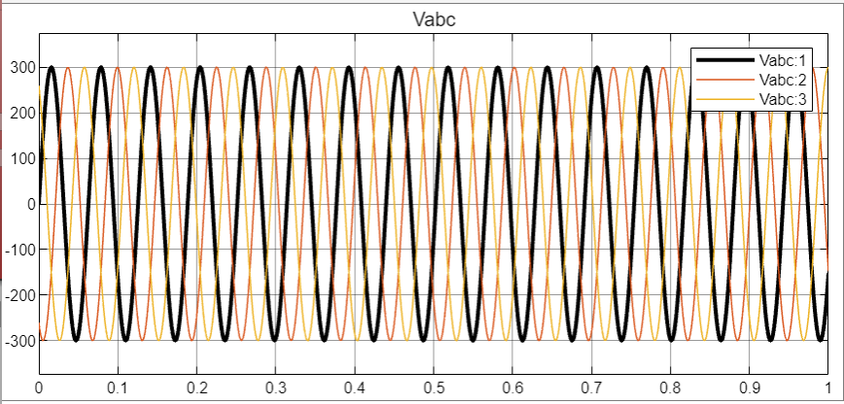

Figure 6: Vabc (100Hz)

## 33Hz Frequency:

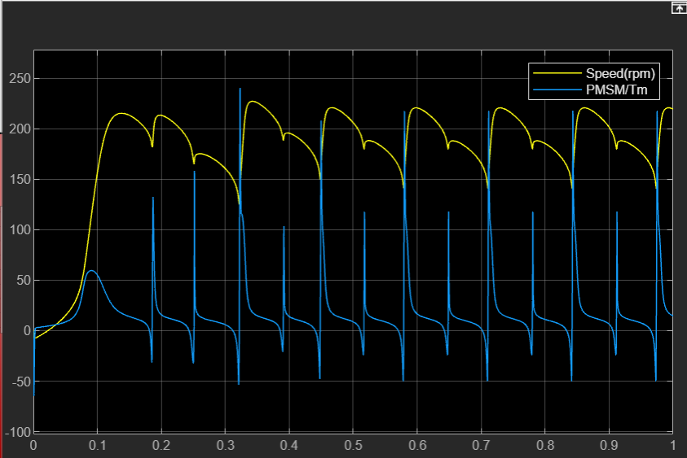

Figure 7: Speed and Trq plot (33Hz)

Figure 8: Iabc (33Hz)

Figure 9: Motor Speed (33Hz)

Figure 10: Theta (33Hz)

Figure 11: Motor Trq (33Hz)

Figure 12: Vabc (33Hz)